To practice for the Accuplacer test:
- Go to vinu.edu. Click on Services:

- Click on Assessment Center in the drop down menu.

- Click on Assessment Practice Sites on left side menu:
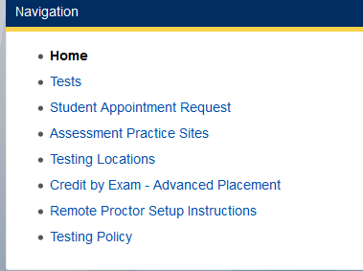
There is a list of links that will take you to different practice tests for the Accuplacer. The Assessment Center recommends the very first site listed: ACCUPLACER National version.
