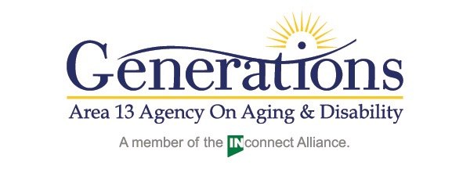

CHECKLIST FOR CURRENT PROVIDERS FOR CONTRACT

JULY 1, 2021-SEPTEMBER 30, 2023

Read the Vendor Memorandum of Agreement carefully. Sign and date page 13 of the agreement. Return copy of the agreement to the address below. A signed copy will be returned to you.
Complete Attachment A

Complete Vendor Contact Specification

Submit current license/certification from the State or other appropriate entity.

Submit recent surveys or audits from other entity(ies)

Submit certificate of liability (Generations must be listed as additional insured)

Submit PERS attachment if applicable

ALL OF THE ABOVE STEPS MUST BE COMPLETED BEFORE APPLICATION WILL BE APPROVED.

RETURN COMPLETED APPLICATION TO:

Cindi Trent Holloway, RN
Community Resource Coordinator
PO Box 314 1019 N. 4th Street
Vincennes, IN 47591

Phone: 812-888-4267
Fax: 812-888-4568
Email: cholloway@vinu.edu

FOR OFFICE USE ONLY
Application complete and filed:______________________

Copy mailed to Provider: ___________________________

June 2021

