Finance – Professional Development
Accounting Tools, Tricks and Tidbits
How do I view my budget?
- How to review your budget and activity using Banner Finance Self-Service.
Utilize the training material located on the Controller’s Webpage at http://survey.vinu.edu/controller/. The training material is currently located under the announcements on the Welcome tab from the Controller’s home page. There is also an on-line training video to view. Also, under the Accounting Tab/ the Accounting/Financial Reporting link and then select the Banner Training tab, there are additional training guides.
If you are in need of Finance training, please email Angie Worland or Conya Wampler to schedule a time.
- How to view your budget using Banner Finance INB (green screen).
From the “Go To” Box, enter the word “BUDGET” if viewing a fiscal fund or enter the word “GRANT” to view a grant fund.

How do I know when the month is closed?
- Finance schedules month end close, six to seven days following the end of each month. An email is sent to designated individuals with the Eprint link to the reports as part of the month end close process. Eprint is an online storage system which houses many reports for the University.
Individuals may also access their previous months report using an Eprint link located on the Employee tab on My VU. Your Banner User ID and Password will be used to access Eprint. By selecting the PDF icon shown below, the most current month on Eprint will automatically load. By selecting the drill icon, users can select previous monthly reports. Eprint contains reports dating back to June 2006.
If you need access to this feature, please contact Angie Worland or Conya Wampler.

What to do when I receive a negative budget balance report?
- Original budget amounts are generally established based on the historically amount expended in the specific account. If a negative budget notice is received, it is up to the responsible individual to determine why there is a variance in the account. Steps to determine the variance include the following:

- Review the activity under FGITRND to determine if all documents have been correctly coded. To correct a coding error, complete a journal voucher form located on the Controller’s webpage under the Accounting/Financial Reporting tab. This form can only be used for expenditures other than salaries and benefits.
- If the expenditure has been correctly coded, review the budget availability and complete an online budget transfer on Finance Self Service. As a general rule, salaries and benefits accounts cannot be transferred.

Where are the cash handling procedures?
- Petty Cash
Petty cash procedures are located under Accounts Payable on the Controller’s webpage under the Policy/Procedures tab and the Petty Cash Reimbursement Form is located under the Forms tab. After obtaining proper signatures, the Petty Cash Reimbursement Form can be sent to Accounts Payable for processing and the employee reimbursement will be paid to the employee via direct deposit.

- Departmental Receipts
On the Controller’s webpage, under the Accounting/Financial Reporting, select the Policy/Procedures tab to view the policies for Safeguarding of Cash and the University Cash Handling. It is University policy that all cash (checks, currency, and coin) collected by University departments and student organizations should be deposited on a daily basis (within twenty-four hours) at the Bursar’s Office. All deposits over $200 are to be made within one business day of receipt. Income of less than $200 must be deposited within five business days of receipt. Funds received but not yet deposited, must be kept in a secure locked device until deposited. When receipts are not deposited in a timely manner, there is a greater chance of it being lost or stolen.

What is the difference between Pass-Thru Fees vs. Non Pass-Thru Fees?

- Pass-Thru Fees = As a general rule pass-thru fees cover a specific instructional cost which is “passed on” to the student. Examples would be magazine subscriptions, tool kits, etc. These fees are accounted for in a unique fund number (#12xxx) which tracks both a revenue account (the actual fees the student pays) and an expense account (the actual vendor cost the pass-thru fee was set up to pay for). Residual amounts in these funds roll from fiscal year to fiscal year.

- Non Pass-Thru Fees = As a general rule non pass-thru fees cover “general” instructional costs and are used to help offset the additional operating cost(s) of the program. Examples would include fees to cover general cost increases in instructional supplies, or high cost programs such as Flight, or specialized instruction such as Music. These fees are accounted for in the general fund (#10000) in the org no. of the instructional department. Any residual amounts from these funds do not roll from fiscal year to fiscal year.

Where is my revenue for pass thru and non pass thru fees?

- Reports to Utilize for Pass Thru and Non Thru Pass Thru Course Fees.
To access these additional reports, logon through My VU and select the employee tab and then the Employee link. Select Schedule Reports to view the Course Fee and Attribute Reports. These reports display the mapping of the data behind the course fees.

How do I budget for pass thru fees?
- An email should be sent to Tim Eaton in the Budget Office with a budget amount. These funds/orgs (12XXX – 2230) need to be budgeted every year.

Where are the Travel Policy/Forms located?
- The travel policies and forms are located under the Controller’s webpage. Select the Accounting tab and then the Accounts Payable link. The Policy and Procedures tab contains the Travel Policy and the Travel Procedures and the Forms tab contains the Travel Voucher form. The Accounts Payable will forward the Travel Voucher form back to the department if a receipt is missing or the form has not been completed correctly. Please contact the Accounts Payable Department if you have questions pertaining to the completion of the Travel Voucher form or questions regarding the travel policy.

How to know if an Invoice with a Purchase Order has been paid on Banner Finance Self Service?

- Access Finance Self Service and select the View Document Link (instructions of how to log on the Self Service is located under the announcements on the Welcome tab from the Controller’s home page. There is also an on-line training video to view).

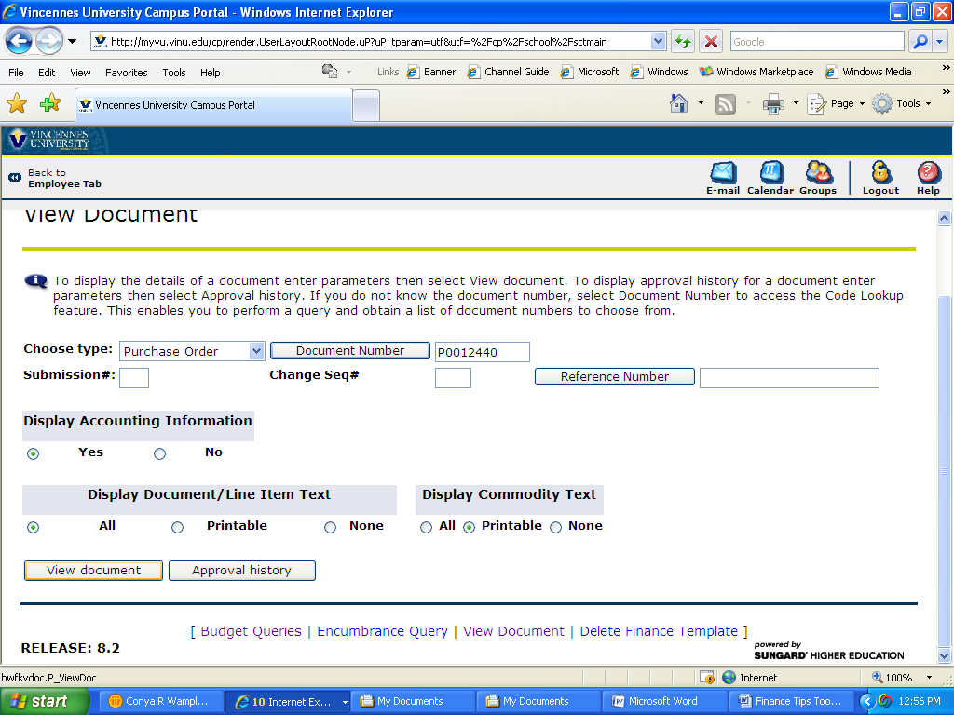

Select View Document and scroll to the bottom of the form. The system will
display the related documents. If there are multiple invoices, select the specific
invoice to display the related check number.

Why is it important to get a W-9 for New Vendors?

- The purpose of completing the W-9 allows the University to properly report and analyze vendor activity if the vendor has had a name change or the owner of the vendor has changed. This also allows the University to properly produce 1099’s to selected vendors as required by the IRS. The W-9 is located on the Forms tab under the Accounts Payable link and the Procurement tab-Purchasing link.

How do I know when a purchase does not require a purchase order and what paperwork do I submit?
- To view Procurement policies, select the Controller’s webpage and then select the Purchasing link. From this link, select the Policy/Procedures tab and select the Purchases Not Involving Purchase Orders link.

How do I review my Outstanding Purchase Orders on Banner Finance?

- From Banner INB, enter FGIOENC in the “Go To” box, type in fund and org, perform next block function. You will see a list of all purchase orders with an open balance.

- From Banner Finance Self Service, select “Encumbrance Query” and enter the Fiscal Year, Chart of Accounts “C”, Fund and Organization (if you are a grant – only enter the Grant number – not the Fund or Organization) and select Submit Query. You will see a list of all purchase orders with an open balance.

How do I know what invoices have been processed against a Purchase Order?

- From Banner INB, enter FGIENCD in the “Go To” box, type in Purchase Order number you want to review, and perform next block function. You will see all entries for subject Purchase Order which includes the invoices processed against the Purchase Order.

- From Banner Finance Self Service, select “Encumbrance Query” and enter the Fiscal Year, Chart of Accounts “C”, Fund and Organization (if you are a grant – only enter the Grant number – not the Fund or Organization) and select Submit Query. You will see a list of all purchase orders with an open balance. You will use the steps shown above. Click on the Purchase order number to drill down on the activity. If you want to see all open and closed purchase orders, select all when querying the activity.

